**Week-09-Two-Dimensional and Multi-dimensional Arrays**

**Reg no : 241001159**

**Name : PADHMAVATHY.M**

**Q1)**

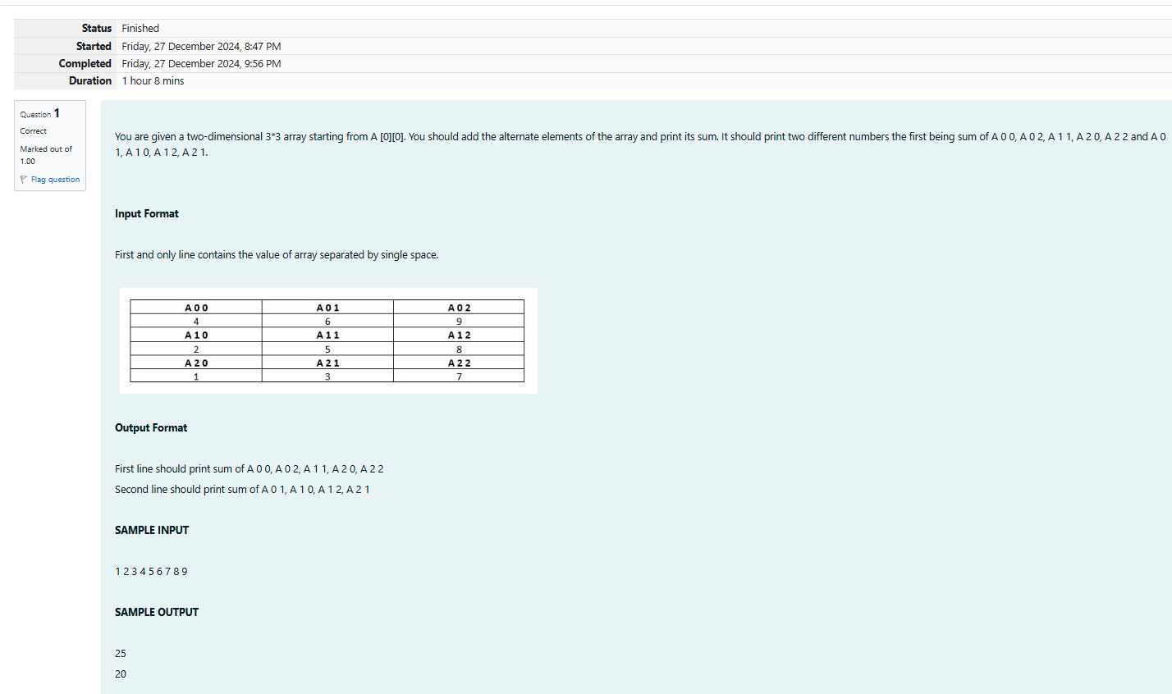

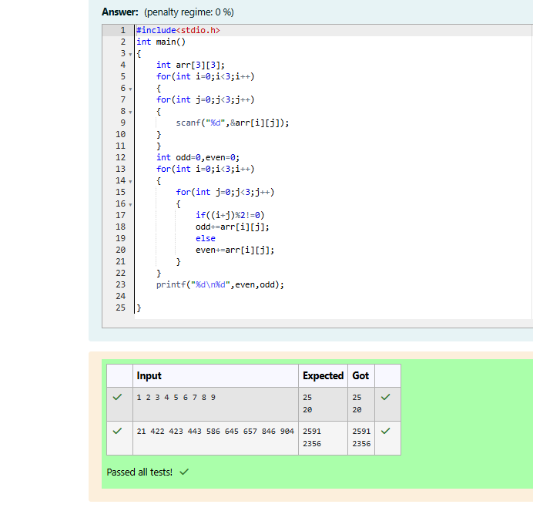

**Reg no : 241001159**

**Name : PADMAVATHY.M**

**Q2)**

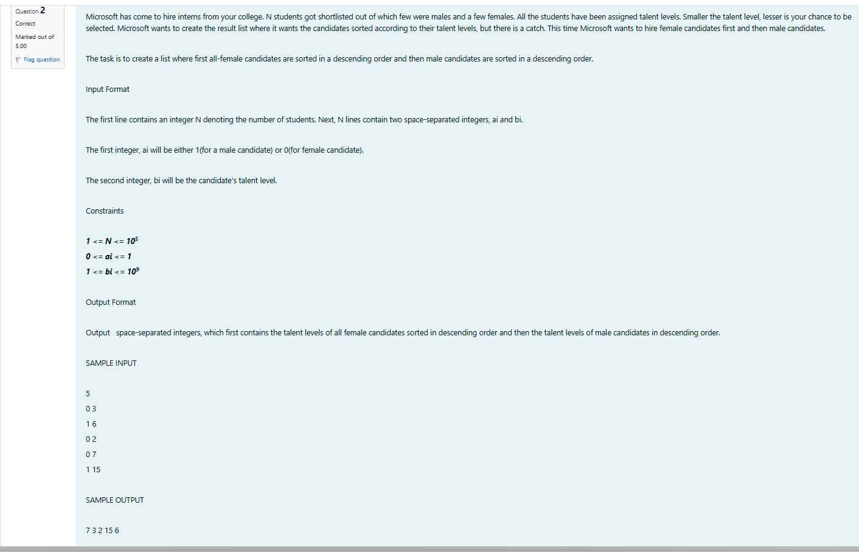

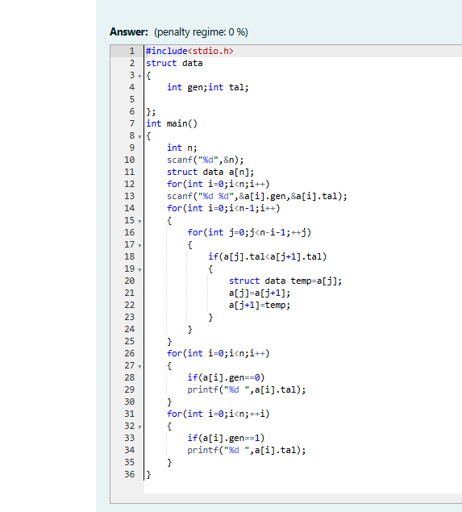

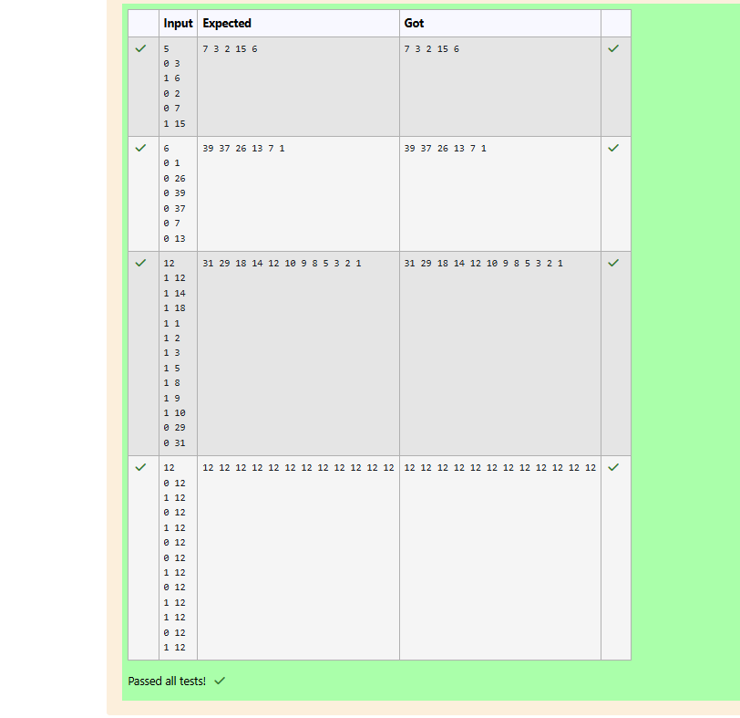

**Reg no : 241001159**

**Name : PADMAVATHY.M**

**Q3)**



